FYP DOCUMENT FORMAT VALIDATOR



By

Zohaib Mehmood
70062940
Adil Bashir
70065622

A Project Report submitted to the
DEPARTMENT OF COMPUTER SCIENCE & INFORMATION TECHNOLOGY
In partial fulfillment of the requirements for the degree of
BACHELORS OF SCIENCE IN SOFTWARE ENGINEERING

Faculty of Computer Science & Information Technology
University of Lahore
Islamabad
December 2021
Copyright © 2021 by UOL Student

All rights reserved. Reproduction in whole or in part in any form requires the prior written permission of Zohaib Mehmood and Adil Bashir or designated representatives.

DEDICATION
We dedicate our dissertation work to all the faculty members of the Department of Computer Science & Information Technology of the University of Lahore, who made this day possible in their life. We are thankful to them who put their efforts into us to develop the skills in us and make us better humans of society.
In Last we dedicate our work to our parents who always supported us in our good and bad. Their prayers brought this day into our life.

DECLARATION
It is declared that this is an original piece of our own work, except where otherwise acknowledged in text and references. This work has not been submitted in any form for another degree or diploma at any university or other institution for tertiary education and shall not be submitted by me in future for obtaining any degree from this or any other University or Institution.

Zohaib Mehmood
70062940

Adil Bashir
70065622

December, 2021

CERTIFICATE OF APPROVAL
It is certified that the project titled “FYP Document Format Validator” carried out by Zohaib Mehmood, Reg. No. 70062940 and Adil Bashir, Reg. No. 70065622 under the supervision of Mr. Ajaz Khan Baig University of Lahore, Islamabad, is fully adequate, in scope and in quality, as a final year project for the degree of BS of Software Engineering.

Supervisor: -------------------------
Mr. Ajaz Khan Baig
Lecturer
Dept. of CS & IT
University of Lahore, Islamabad

Internal Examiner: -------------------------
Mr. Mehmood
Lecturer
Dept. of CS & IT
University of Lahore, Islamabad

Internal Examiner 2: -------------------------
Mr. Touseef Sajjid
Lecturer
Dept. of CS & IT
University of Lahore, Islamabad

Project Coordinator: -------------------------
Mr. Ajaz Khan Baig
Project Coordinator
Dept. of CS & IT
University of Lahore, Islamabad

HOD: -------------------------
Dr. Raja Habib Ullah
HOD
Dept. of CS & IT
University of Lahore, Islamabad

ACKNOWLEDGMENT
We would like to express our special thanks of gratitude to our supervisor “Sir Ajaz Khan Baig” for their guidance and support in completing our Project. I would also like to extend my gratitude to the Ms. Itrat Fatima and other faculty for helping and providing us with all the facilities that were required.
Date: July 18, 2022

ABSTRACT
We are developing a website for checking the format of document. In this day and age of digitization, our professional and non-professional lives are filled with documents whether they are assignments of a students, ads for recruitments, a proposal for business project or legally binding documents. All of these documents are being made electronically on computer or laptops. Moreover, the most important thing in all these types of documents is their format and styling (How data is presented). Although there are, tools for such work but there are no tools that can check the formatting and styling of said documents. There is need of platform where user can check document’s format by setting custom parameters to be checked in given file.
The purpose of this web base project is to provide an easy way to check format/style of documents by making a platform where users can upload their files and check their formatting/styling against one of the pre-set parameters or parameters set by themselves. At the end, system will highlight any mistakes that do not match the given parameters if they exist.
Website will be a product where it will allow new user to register and then after successful registration, he can login. After login, the user will be in homepage of website where he will upload his file and set some parameter to be checked. It will read file data and then after matching given parameter and file, data user will be given report of error in file. The website will be secure no unauthorized person can use it. The website will have an encrypted login page and will use a secure host. The uploaded file will also be deleted as soon as the results of the file are scanned and results are shown.
This website will help its users to cross check documents in a short span of time instead of checking them manually line by line. Moreover, it will enable its users to have a secure, fast, time saving and a user-friendly environment to examine respective documents as stated above. The project is designed in a way that a person having less knowledge of using internet will also be able to use this feature without any trouble. Thus, helping in better utilization of resources.

TABLE OF CONTENTS
DEDICATION iv
DECLARATION v
ACKNOWLEDGMENT vii
ABSTRACT viii
TABLE OF CONTENTS ix
LIST OF FIGURES xii
LIST OF TABLES xiii
Chapter 1 1
INTRODUCTION 1
1.1 Overview 1
1.2 Statement of Problem 2
1.3 Purpose of The Research/Project 2
1.4 Applications of The Research 2
1.6 Summary 4
Chapter 2 5
LITERATURE REVIEW 5
2.1 Related Technologies 5
2.2 Related Projects 9
2.3 Related Studies 9
2.4 Limitations and Bottlenecks 9
2.5 Summary 10
Chapter 3 11
TOOLS AND TECHNIQUES 11
3.1 Hardware Used with Technical Specifications 11
3.2 Software(s), Simulation Tool(s) Used 11
3.3 Summary 14
Chapter 4 15
METHODOLOGIES 15
4.1 Design of The Investigation/Algorithms/ Hardware 15
4.2 Analysis Procedures 16
4.2.1 Functional Requirements 17
4.2.1.1 Regitser 17
4.2.1.2 Sign-Up/Sign-in 17
4.1.2.3 Set Parameter 17
4.1.2.4 Upload File 17
4.1.2.5 Download File/ Show Results 17
4.2.2 Non-Functional Requiremnts 17
4.2.2.1 Usability 17
4.2.2.2 Reliability 17
4.2.2.3 Avalaibility 17
4.2.2.4 Security 17
4.2.2.5 Performance 17
4.2.2.6 Portability 17
4.2.3 Flow Chart Diagram 17
4.2.4 Data Flow Diagram 18
4.2.5 State Transition Diagram 19
4.2.6 Use Cases 22
4.2.7 Sequence Diagram 25
4.3 Implementation Procedure 29
4.4 Verification of Functionalities 33
4.5 Summary 43
Chapter 5 44
SYSTEM TESTING 44
5.1 Objective Testing 44
5.2 Usability Testing 44
5.3 Software Performance Testing 44
5.4 Compatibility Testing 45
5.5 Load Testing 45
5.6 Reliability Testing 45
5.7 Security Testing 46
5.8 Database Testing 46
5.9 Test Cases 46
5.10 Summary 47
Chapter 6 50
RESULTS AND CONCLUSION 50
6.1 Presentation of The Findings 50
6.2 Discussion of The Findings 51
6.3 Limitations 51
6.4 Recommendations 51
6.5 Summary 51
6.6 Conclusion 52
Chapter 7 53
FUTURE WORK 53
7.1 Paragraph Spacing 53
7.2 Indentation 53
7.3 Margins 53
7.4 Header and Footer Content 53
7.5 Text Color 53
7.6 Bullet list 54
7.7 Tables Cell Contents 54
7.8 Summary: 54

LIST OF FIGURES
Figure2. 1 Grammarly Interface 5
Figure2. 2 Plagiarism Checker 6
Figure2. 3 ProWritingAid Interface 7
Figure2. 4 Linguix 8
Figure2. 5 Slick Write 8
Figure 4. 1 Flow Chart Diagram 18
Figure 4. 2 DFD-Level 0 Diagram 19
Figure 4. 3 State Transition Diagram 21
Figure 4. 4 Use Case Diagram 22
Figure 4. 5 Sign Up Sequence Diagram 26
Figure 4. 6 Sign -In Sequence Diagram 27
Figure 4. 7 Complete Sequence Diagram 28
Figure 4. 8 System Diagram 29
Figure 4. 9 Sign-Page 30
Figure 4. 10 Sign-In Page 31
Figure 4. 11 Main Menu 32
Figure 4. 12 Successfully Signed-In 33
Figure 4. 13 Invalid Sign-In 34
Figure 4. 14 Sign-Up Successful 35
Figure 4. 15 Unregistered User 36
Figure 4. 16 Password Not Matched 37
Figure 4. 17 Invalid Email 38
Figure 4. 18 File Upload Successful 38
Figure 4. 19 Test Document 1 39
Figure 4. 20 Test Document 2 40
Figure 4. 21 Correct Table 40
Figure 4. 22 Incorrect Table 41
Figure 4. 23 Picture Test Document 41
Figure 4. 24 Final Report Test Document 1 42
Figure 4. 25 Final Report Test Document 2 43

LIST OF TABLES
Table 3. 1 Tools and Techniques 11
Table 3. 2 Technical Specification 11
Table 4. 1 Use Case Sign-Up 23
Table 4. 2 Use Case Sign-In 24
Table 4. 3 Use Case Set Parameters 24
Table 4. 4 Use Case Upload File 25
Table 4. 5 Use Case Download File 25
Table 5. 1 Test case 1 Functional Testing 47
Table 5. 2 Test Case 2 Security Testing 47
Table 5. 3 Test Case 3 Functional Testing 48
Table 5. 4 Test Case 4 Database Testing 48
Table 5. 5 Test Case 5 Performance Testing 48
Table 5. 6 Test Case 6 Functional Testing 49

Chapter 1

INTRODUCTION
This project is website based designed for the betterment of the new generation. The purpose of this web base project is to provide an easy way to check format/style of documents by making a platform where users can upload their files and check their formatting/styling against one of the pre-set parameters or parameters set by themselves. At the end, system will highlight any mistakes that do not match the given parameters if they exist.
The main objectives of this website application are as following:
- Users are able to create an account conveniently and can register themselves on the website so that they can check formatting of their document.
- After logging in, user can select the parameters to be checked.
- User will upload any document with extension of docx.
- It only accepts files that has .docx extension.
- It will prompt error message if file type is not .docx.
- Download button will appear so that the user can download the document.
- The document will have underlined words having parameters other than given ones.

Overview
In this day and age of digitization, our professional and non-professional lives are filled with documents whether they are assignments of a students, ads for recruitments, a proposal for business project or legally binding documents. In universities final year project is very important and documentation of FYP is very critical. Final year project report needs to be formatted properly. All of these documents are being made electronically on computer or laptops. Moreover, the most important thing in all these types of documents is their format and styling (How data is presented). Although there are, tools for such work but there are no tools that can check the formatting and styling of said documents. There is need of platform where user can check document’s format by setting custom parameters to be checked in given file.

1.2 Statement of Problem
In this era of modernization, everyone still checks documents manually which is time consuming and requires a lot of energy to do so. The number of students passing out from university is increasing rapidly. Final year project documentation is necessity and its most important aspect is format. On average there are minimum 100 to 150 students passing from each university making a total of 50 to 60 documents that need to be checked manually which requires a lot of human effort. At this moment anything that can reduce this workload has quite scope globally as our lives are somehow filled with documents either assignments, presentations or other kinds of documents. The others systems provide less efficiency and less effectiveness as no such task is being performed. So far there is no proper system that helps users to check their documents thoroughly and provide output with highlights of errors.
In this project, the traditional system of document checking is to be shifted into digital system as it will help us to work efficiently. People spend a lot of time checking documents usually students while doing their assignments, teachers while checking assignments, projects, business related people while rechecking their proposals, tasks, etc. Most of the time they have to hire people to perform such tasks for them. Our aim is to reduce the work load of all those who are surrounded with checking documents so that they can quickly perform their jobs without any stress and saving most of their time.

1.3 Purpose of the Research/Project
The purpose of this web base project is to provide an easy way to check format/style of documents by making a platform where users can upload their files and check their formatting/styling against one of the pre-set parameters or parameters set by themselves. At the end, system will highlight any mistakes that do not match the given parameters if they exist.

1.4 Applications of the Research
This project will be applied to reduce the work load of people having their lives filled
with documents i.e., offices, universities and in every organization where word format files are used.
The proposed system helps its users to check formatting of their documents. The website is quite efficient and works smoothly. A user with less knowledge of internet can also use this site easily without facing any problem because of user friendly and simple environment. User can download the file again to check mistakes in document as all the words having different parameters would be underlined making it easy for user to correct them.

1.5.1 Chapter 1
It is a background of the study will be overviewed including the Problem Statement, Purpose of the Study, its significance. It's website main aim that system is filling in this project.

1.5.2 Chapter 2
It will present an overview of related technologies, work, and projects done by other researchers in this field. There are a lot of related technologies that are being used in this field. System needs to cover the best of software work on this website to make it better for the future.

1.5.3 Chapter 3
It will have a detail of Tools and Techniques as you know every project need is hardware and software tools. Which are very important for every project. So, in this chapter the detail preview of hardware and software is used for Document Format Validator.

1.5.4 Chapter 4
It will present in detail the applying methodology of application creation of datasets, the architecture of models used in this study, and methods to train and validate them.

1.5.5 Chapter 5
This section presents in detail the system testing of an application as objective testing, usability, system performance. We performed usability testing to ensure usability of website is good. We performed performance testing to make our user getting the best performance from our website. Security is not taken lightly too. We made sure no outside user is able to access out system. We made test cases and show how system is responding in certain conditions

1.5.6 Chapter 6
It will have the results of the methods and techniques discussed in chapter 4 and will have graphical and tabular representation of those results with detailed discussions.

1.5.7 Chapter 7
In this section we mentioned the improvements we can add to our current project. Because there is always need of change no matter how perfect your system is. Future works will also be discussed in this chapter. At the end of this thesis, references will be given.

1.6 Summary
In this era of modernization, everyone still checks documents manually which is time consuming and requires a lot of energy to do so. At this moment anything that can reduce this workload has quite scope globally as our lives are somehow filled with documents either assignments, presentations or other kinds of documents. The purpose of this web base project is to provide an easy way to check format/style of documents by making a platform where users can upload their files and check their formatting/styling against one of the pre-set parameters or parameters set by themselves. At the end, system will highlight any mistakes that do not match the given parameters if they exist.

Chapter 2

LITERATURE REVIEW
According to best of knowledge not many such websites are available, before initiating the project of Document Format Validator, we studied about the related projects which are already in the market, circumstances, we thoroughly studied their defects and find out that there is no such project that check the format. We are building a website to fulfill the demand of checking documents format This chapter will describe how the existing work is helping the people and how our project will more contribute in it. There are many pre-developed projects which are currently being used by individuals but most of those websites are not for Pakistan.

2.1 Related Technologies
Related technologies related to our work are Grammarly, and Plagiarism checker, ProWitingAid, linguix and slick Write.

2.1.1 Related Technology 1
Grammarly is a Ukrainian-origin American-headquartered cross-platform cloud-based writing assistant that reviews spelling, grammar, punctuation, and clarity, engagement, and delivery mistakes. It uses AI to identify and search for an appropriate replacement for the mistake it locates. Grammarly works by using context, not just word referencing, to fix your sentences. The app is available for free in different versions, whether as a Chrome extension or desktop app, among others.
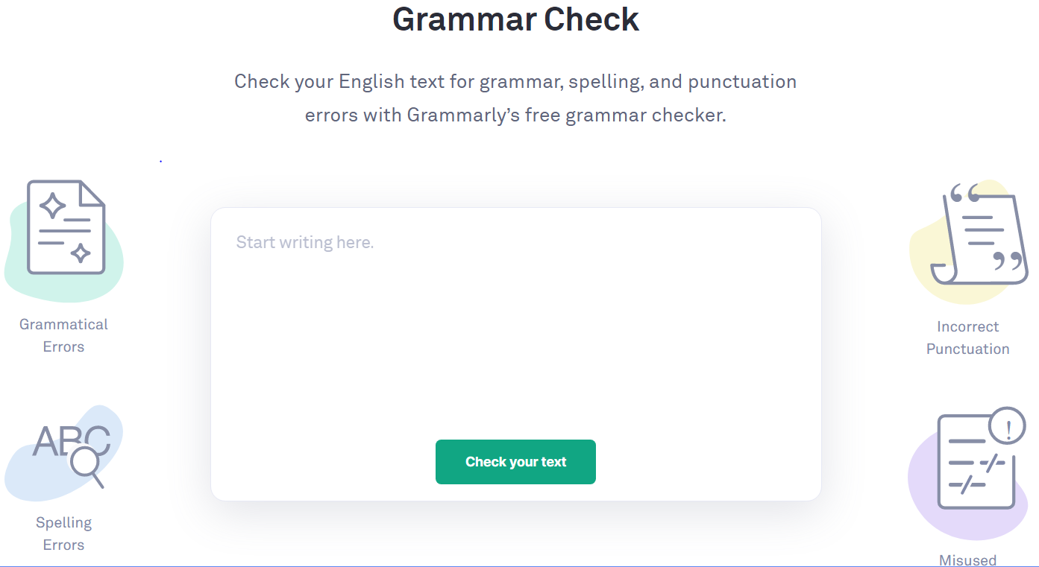
Figure2. 1 Grammarly Interface
In figure 2.1 there is interface of Grammarly which consist of a text editor box where user will write its paragraph in which he/she wants to check his grammar. After typing or copy/paste the text in editor, user will click on “check your text” box. This will run the Grammarly and it will check for grammar mistakes in your text and will highlight any mistakes if found in your text.

2.1.2 Related Technology 2
A plagiarism pattern checker detects and exhibits a plagiarized content, whether intentional or not. With the introduction of plagiarism detectors, the identification of duplicate contents has turned more straightforward and thus providing a substantial solution to the issue. In figure 2.2 user will paste his text or upload file and plagiarism detector will process the data and generate the report of matching data from any websites or any place from where data has been copied.
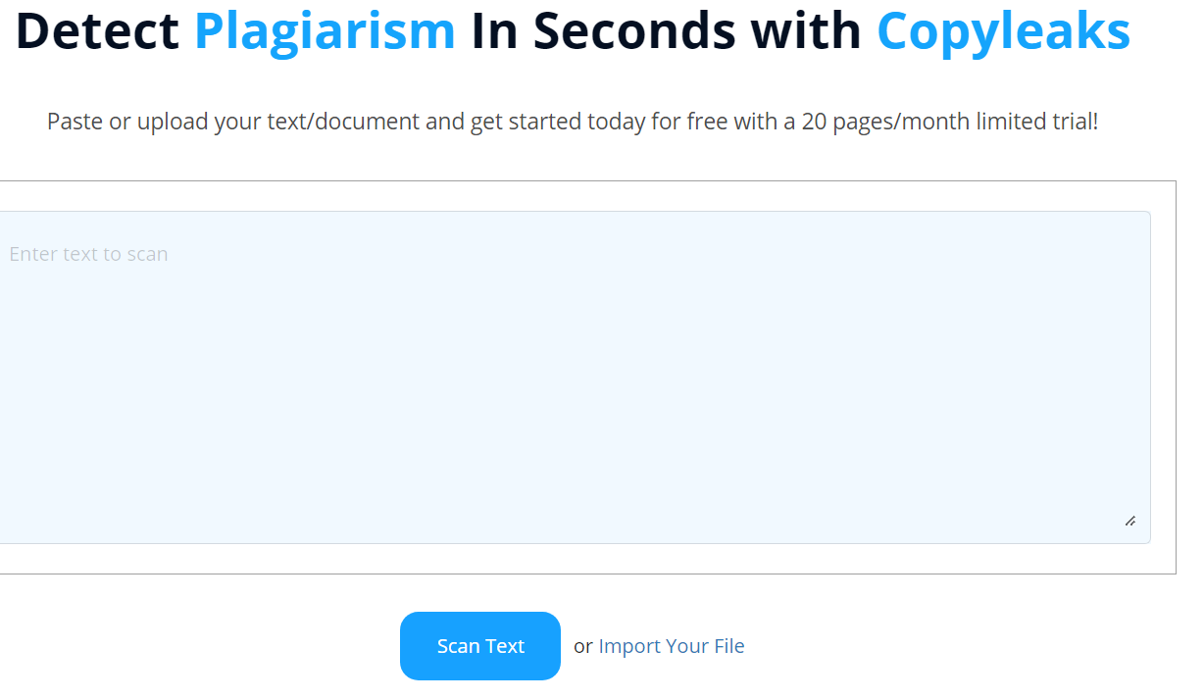
Figure2. 2 Plagiarism Checker

2.1.3 Related Technology 3
ProWritingAid is a premium grammar checker and style editor for bloggers, novelists and business writers. This software helps users eliminate errors, optimize word choice and edit grammar and punctuation faster. It aids in checking blog posts, articles books, an editor’s note, and any other content you want to be checked. ProWritingAid editing software is available via web browsers on both Windows and Mac. It also supports Microsoft Word, Google Docs and, interestingly, the popular book writing app Scrivener. At the time of writing this review, the company didn’t offer dedicated apps for iOS or Android. Although anyone can use this tool for proofreading and grammar checking their content, it's particularly suitable for fiction writers.
In figure2.3, there is interface of ProWritingAid it is similar to word with some extra features like grammar and sentence structure checking.
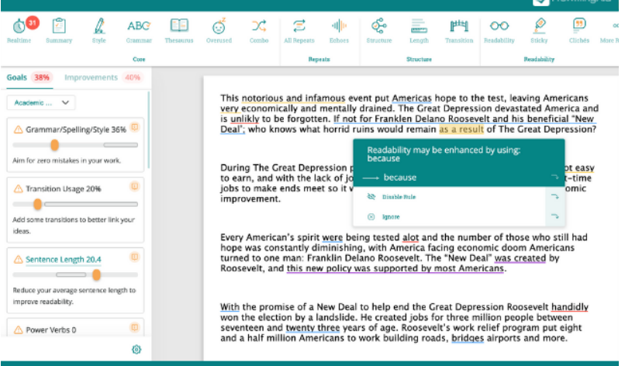
Figure2. 3 ProWritingAid Interface

2.1.4 Related Technology 4
Linguix is an AI-controlled composing aide which can spruce up your composition and pass on it blunder free for others to appreciate or consume for the reason to which it was planned. It has ability to deliver to you the excellent substance that is without spelling, syntactic and complex errors.
What's more, it covers a wide range of content as well, whether you really want to deliver a scholar or logical paper, a business report, a virtual entertainment or post or something totally different. Basically, reorder your substance into the Linguix altering device, and watch as it scrutinizes its data set for ideas to lift your composition.
There is likewise an extraordinary assortment of content layouts which you can use to begin your composition - never the simplest piece of the go back over. What's more, Linguix additionally offers premium degrees of safety which means having profoundly delicate composing looked at is never a worry all things considered.
In figure 2.4 Linguix same as other editor you can add text or copy paste and it will assist you in writing
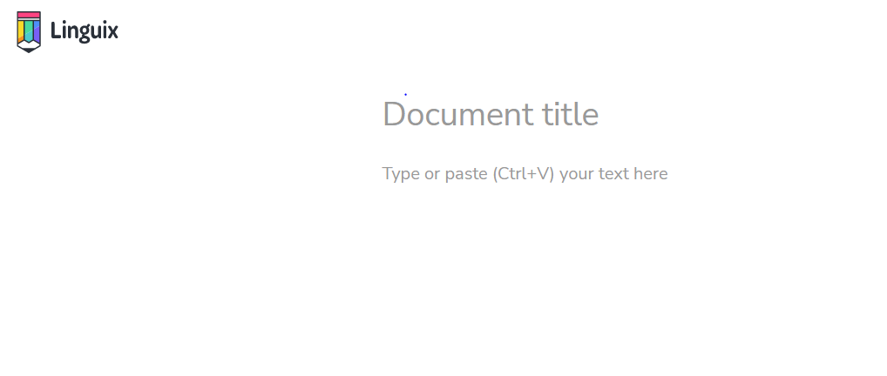
Figure2. 4 Linguix

2.1.5 Related Technology 5
Slick Write is a strong, free application that makes it simple to really look at your composition for syntax blunders, expected elaborate mix-ups, and different elements of interest. Whether you're a blogger, writer, SEO expert, or understudy composing a paper for school, Slick Write can assist with taking your composition to a higher level. It is used widely because attempt the no product download or establishment is required.
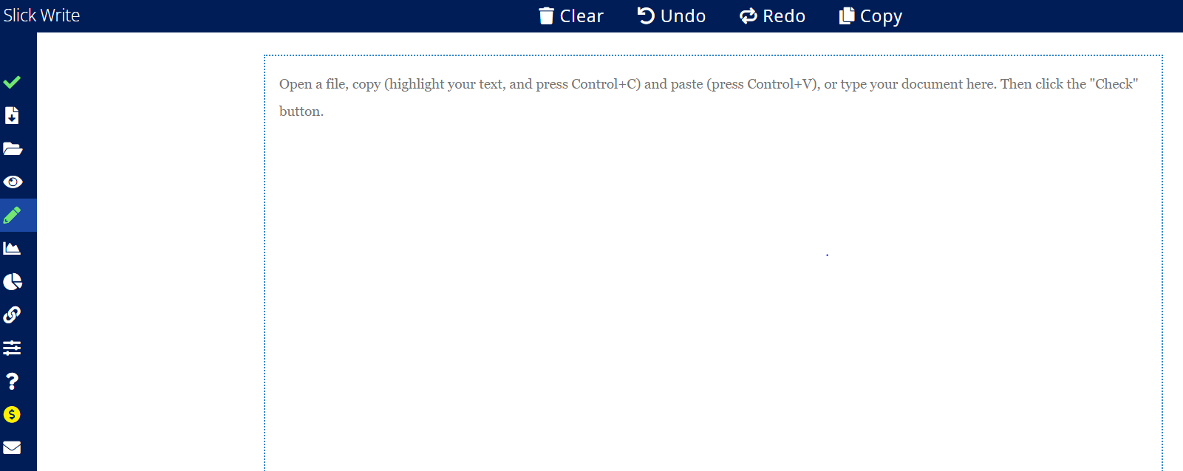
Figure2. 5 Slick Write
In figure 2.5 there is slick write interface where user will attempt type its text or copy paste or upload a file. Its working is same as other editors.

2.2 Related Projects
Some projects related to our project are listed below.
- Grammarly.
- Plagiarism Pattern Checker.
- ProWritingAid
- Linguix
- Beewriter
- White Smoke
- Slick Write

2.3 Related Studies
The major ongoing research in documentation is Grammarly an application that used to correct errors in writing abstract English text can save you from misspellings, grammatical and punctuation mistakes, and other writing issues on all your favorite websites. Research papers that need to be published has a specific format. Tools are available to help you write a paper according to format. e.g., Papersowl.com, Zotero and Endnote. There are many working researches that help in checking format of paper as well as some certain field. Inspired by fact, researcher have identified different tools for helping in writing to improve writing quality. But building such technology enabled personalized writing and formatting domain is complicated and time-consuming task. The current article presents a simple approach of building a Document Format Checker to give importance to personalized content delivery with special consideration to the flexibility of domain independence of document checker to facilitate project coordinators to experiment with document format validator.

2.4 Limitations and Bottlenecks
Grammarly is used to check grammar it does not helps you in checking the format. Another disadvantage of Grammarly is vagueness. You must make most changes yourself. The automated tool makes suggestions, but you need to change them yourself. But what if you’re overwhelmed? If you’re confused by grammar, that does not always help. You end up doing most of the work yourself. Lags are noted in the ProWritingAid, especially when you throw to it a massive document or a book, maybe something like 500 pages at once for editing. Plagiarism Pattern Checker is completely different story. It only tells the sources of copied data. Linguix works like Grammarly and SlickWrite is also only helpful in checking sentence structure and punctuation. In short, they all are helping you in checking grammar and plagiarism but none of the above mentioned is offering of format checking.

2.5 Summary
In this section some related works are covered such as Grammarly, ProWritingAid, and Plagiarism pattern checker including their drawbacks and facilities they lack which is a requirement for user. Role of related works has been very important while the development of this website. Many errors were found while developing this project but they were being solved with the help of these related works and research papers. They were also helpful making the site more effective, accurate and simple to use.

Chapter 3

TOOLS AND TECHNIQUES
There are some tools and technology primarily refer to the software, languages and devices that are used in the development of format validator. These are hardware based or software-based tools. During implementation of this application.
Tools or Applications | Tools | Rationale
Tools or Applications | Visual Studio Code | Coding Tool
Tools or Applications | React JS | Frontend Development
Tools or Applications | Node JS | Backend Development
Tools or Applications | Fire Database | Authorization of person
Tools or Applications | Microsoft Word | For Documentation
Tools or Applications | Microsoft Power Point | For Presentation
Tools or Applications | Microsoft Visio | For diagrams and Flow charts
Table 3. 1 Tools and Techniques

3.1 Hardware Used with Technical Specifications
The following table lists the minimum and recommended hardware requirements for the web application.
Component | Minimum | Recommended
Processor | - 1.9 gigahertz (GHz)  - X86- or x64-bit dual core processor. | - 3.3gigahertz (GHz).  - Faster 64-bit dual core processor.
Memory | 2-GB RAM. | 4-GB, 8-GB or More
Display | Super VGA with resolution of 1024*768. | Super VGA with resolution of 1024*768
Table 3. 2 Technical Specification

3.2 Software(s), Simulation Tool(s) Used
Following applications have been used for development of this project:

3.2.1 React JS
To foster the responsive Front-End of this item, React JS is utilized. Framework are made by involving JSX in project. Respond is written in 2 ways. One way is to compose the code in JSX and second way is typescript. Both are extremely valuable in making any sort of sites. Framework are bringing in an excess of libraries for the advancement of site. A few libraries are generally utilizing in each undertaking. Designers can import it from the web utilizing a few sorts of naming.

3.2.2 Node JS
Node.js is an open-source, cross-platform, back-end JavaScript runtime environment that runs on the V8 engine and executes JavaScript code outside a web browser. Here are some key features of Node JS:
- Node.js is an open-source server climate.
- Node.js is free.
- Node.js runs on different stages. (Windows, Linux, UNIX, Mac OS X, and so on)
- Node.js utilizes JavaScript on the server Here is the manner by which Node.js handles a document demand.
- Sends the errand to the PC's document framework.
- Prepared to deal with the following solicitation.
- Whenever the document framework has opened and perused the record, the server restores the substance to the client.
What is a Node.js File?
- Node.js documents contain undertakings that will be executed on specific occasions
- A normal occasion is somebody attempting to get to a port on the server. Node.js documents should be started on the server prior to having any impact. Node.js records have augmentation ".JS". Hub is utilized to create the backend of the product.
Why are we using Node JS?
- Node JS is utilized to create the backend of the product.
- High-performance for Real-time Applications.
- Easy Scalability for Modern Applications.
- Cost-effective with Full stack JS.

3.2.3 Microsoft Visio
Microsoft Visio is software for drawing a variety of diagrams. These include flowcharts, org charts, building plans, floor plans, data flow diagrams, process flow diagrams, business process modeling, swim lane diagrams, 3D maps, and many more. We used Microsoft Visio for drawing diagrams like use case diagram, flowchart diagram, sequence diagram, state transition diagram, activity and system diagram. The main reason for choosing Visio is its simplicity. It is easy to use and have all picture and structure available to draw any diagram for any system.

3.2.4 Fire Database
The Firebase Realtime Database is a cloud-facilitated information base in which information is put away as JSON. The information is synchronized progressively to each associated client. By utilizing a solitary API, the Firebase data set furnishes the application with the current worth of the information and updates to that information.
The benefit of Firebase Hosting allows you to set-up a single-page, a mobile landing page, web page or progressive web page with ease. We are using Fire Database for authentication of our user.

3.2.5 Visual Studio Code
Visual Studio Code is a smoothed-out code manager with help for improvement activities like troubleshooting, task running, and form control. It intends to give simply the instruments an engineer needs for a fast code-construct investigate cycle and passes on more perplexing work processes to more full included IDEs, like Visual Studio IDE.
Visual Studio Code option a lighting quick text file editor, good for everyday use. VS code helps you to be productive with syntax lightness, bracket matching and auto indentation. We used it as our editor to code our website design and functions

3.2.6 Microsoft PowerPoint
It allows users to create visual presentations comprised of individual slides. Microsoft PowerPoint is easy-to-use presentation software that runs on Microsoft Windows and Mac OS operating systems. PowerPoint is commonly used by business people and students to create slide show presentations.
We used PowerPoint to present and defend our project in presentations.

3.2.7 Microsoft word
Microsoft Word allows you to create professional-quality documents, reports, letters, and résumés. Unlike a plain text editor, Microsoft Word has features including spell check, grammar check, text and font formatting, HTML support, image support, advanced page layout, and more. It is easy to use and documentation making in MS word is easy and it is efficient. That’s why we selected Microsoft to be our documentation tool.

3.3 Summary
Tools and techniques are very important aspect to be considered to build quality application. This chapter presents related project, technologies and their insights and outsights. We have utilized most recent variant of web programming dialects to make our web modules responsive and alluring. We used most advanced and efficient tools that are available to make our product runs smoothly. For backend development we used Node JS and for front end development we used ReactJS. For diagrams and flowcharts, we used Microsoft Visio and Microsoft Word for documenting our project. PowerPoint is used to present the project for evaluation and approvals of evaluators. Firebase is used to authenticate user that are trying to log-in or sign-up in our system. And in the end Visual Studio Code due to it lightning speed was our coding editor that helped us in completing our project right on time.

Chapter 4

METHODOLOGIES
This is the actual center of our work. We have used different techniques to make our project more efficient. We used a reliable framework which fulfills our requirements and helps us in presenting data more clearly. User interface was designed keeping the user interest in mind and is very simple. Even a first-time user can understand it and use it efficiently.

4.1 Design of the Investigation/Algorithms/ Hardware

4.1.1 System Design
In the framework configuration stage, a reliable framework is created which fulfills the given prerequisites. The setup time of programming headway figures out how to change programming necessities into a legitimate working framework.

4.1.2 User Interface Design
It is worried about the interest between a client and the site. It is worried about everything from beginning the system or stamping into the structure to the conceivable demonstration of needed wellsprings of data and yields. It assists us with associating with the client with the site. On the off chance that the site is very much outfitted and all bugs are settled, the UI is best for the client. Key features of our user interface are:
- System is easy to use and user friendly.
- First time user can also understand it because system guides you to what to do next.
- UI is eye catching and pleasant.
- User will be notified of any error occurred during their time on website.
- Users are in total control of what they do and how they do on website.
- User interface is single page.
- Color combination of user interface is light.
- User can change color according to their will.

4.2 Analysis Procedures
A different portion of this product needed to be analyzed thoroughly. Choice of final year project is always difficult. We have to give final year report. We find out that there is not such tool that is helping students in format checking. We later discussed with project coordinator and we are surprised when we find out even, they check formatting of final reports manually. Checking manually takes a lot of time and efforts. We decided to automate this process. Proper meetings with project coordinator are scheduled. In meetings we asked them about basics of format checking and what are the parameter that are important in final report. They gave us a long list of formatting parameter. Font-size, font-family, text-size, image justification, table justification, text justification was some of the most important parameters in document. We made structure and different diagrams to help in understanding the working of our document format validator. We also obtain some functional requirements of system from team that was checking documents manually at that time.

4.2.1 Functional Requirements
Functional requirements are product features or functions those developers must implement to enable users to accomplish their tasks. Functional requirement of the document format validator are as follow:

4.2.1.1 Register
Users will be able to register themselves to the website by providing their email address and setting up a unique password, which will allow them to use its web-based services.

4.2.1.2 Login/Logout
After registering users will able to log-in with the e-mail and password set at the time of registration. User will be able to log-out as well. After logging out of the system user will be shown homepage of website.

4.2.1.3 Set Parameters
A set of format/styling options e.g., font size, font style, margin, line spacing etc. will be provided so that the user can set the desired parameters to check the format/style of their file. User will be given a drop down menu to select tge property he want to check.

3.2.1.4 File Uploading
A drag-and-drop box as well as an “upload” button will allow the users to easily upload their desired file on the website and check its format.

3.2.1.5 Download File/Show Results
After scanning the file against set parameters, the website will point out the shortcoming if any to the user. It will mark the pages where the document doesn’t comply with the set parameters and also point out which parameters aren’t a match.

4.2.2 Non-Functional Requirements

4.2.2.1 Usability
The website shall be used friendly and does not require any guidance to be used. In other words, the website will be as simple as possible, so its users shall use it easily. Actually, the interface is quite simple and straight forward so that anyone can understand it.

4.2.2.2 Reliability
Under the given pre-conditions of have a stable internet connect and a web-browser the website service won’t experience any failure for 95% of the week.

4.2.2.3 Availability
As this website attracts users from different aspects of fields and different time zones thus the website will be made available to them 99% of the time day.

4.2.2.4 Security
The website will be secure no unauthorized person can use it. The website will have an encrypted login page and will use a secure host. The uploaded file will also be deleted as soon as the results of the file are scanned and results are shown. The uploaded file will not be kept in any form of storage once the results are shown, everything will be deleted. A filter will be used to make sure no unauthorized person can peep at the file while it is being uploaded. We have tested the system and it is working fine. No unauthorized user is able to login to system.

4.2.2.5 Performance
All the elements for the website e.g. buttons and parameters will be made quite responsive (e.g. give response to a click in 0.001sec) to give the user a comfortable experience.

4.2.2.6 Portability
As this is a web-based service thus any device that has a stable internet connection and a web-browser can use this service.

4.2.3 Flow Chart Diagram
A flowchart is a diagram that shows how a workflow or process works. A flowchart is a diagrammatic representation of an algorithm, or a step-by-step procedure for completing a task. The flowchart depicts the stages as various types of boxes, with arrows linking the boxes to demonstrate their order.
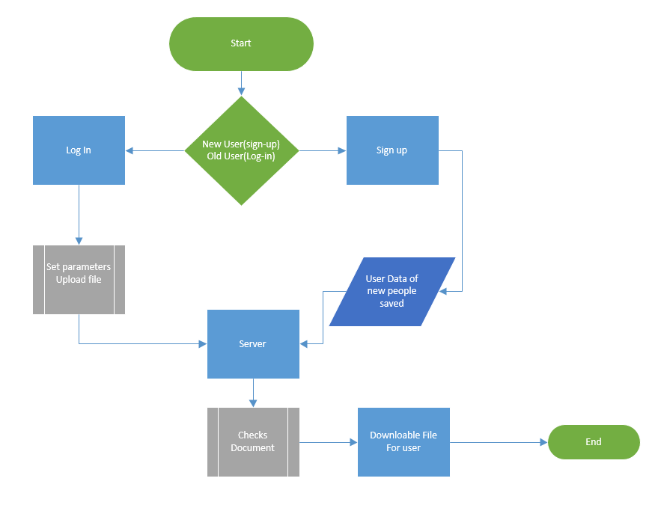
Figure 4. 1 Flow Chart Diagram
In figure 4.1 we have Flow Chart Diagram where we have 2 process sing-up and sign-in differentiated by decision. After selecting any process, the system will move forward to its next process where user will set parameters and new users’ data will be saved after setting parameters user will upload a file and wait for system to give a file that will modified where format is not according to set parameters.

4.2.4 Data Flow Diagram
Data flow diagram is a diagram in which we make a diagram which shows us about the flow of the data in the system. The level 0 is a DFD in which we connect the user with the system and track the flow of information in the system by all the users. It’s a data flow diagram of level 0 which is so simple and everyone can easily understand the connected flow of the paths with the main system.
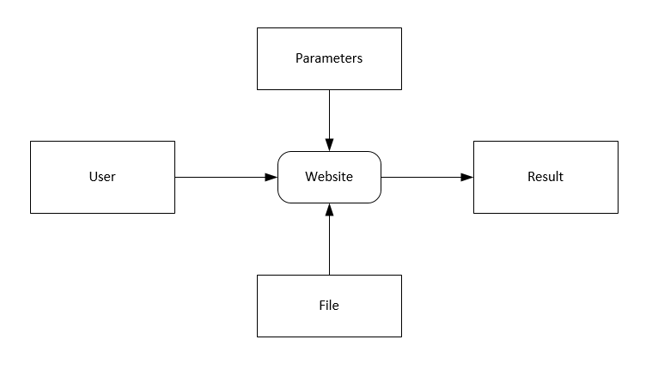
Figure 4. 2 DFD-Level 0 Diagram
In figure 4.2, we have shown how data will flow in our system. User will signup on website. User data will come on our server then parameters and file will be selected.
Then at last user will be given modified file in which mistakes will be highlighted.

4.2.5 State Transition Diagram
State-transition diagrams show all of the states that an item can have, as well as the events that cause it to change state (transitions), the requirements that must be met before the transition can take place (guards), and the activities that occur over the object's lifetime (actions).
State: Sign-Up
Action:
- Provide your information.
- Correct information provided user will be saved for future log-in.
- Incorrect information will prompt an error.
State: Sign-In
Action:
- Enter you login credentials.
- For valid credential sign in request will be passed.
- For invalid credential user will not be able to log-in to the system and will get an error message.
State: Homepage
Actions:
- Set your font size.
- Set your font style.
- Set your font family.
- Upload a valid file type document.
State: Download File
Actions:
- Click on “Download” Button to download your modified file.
Sate: Log-out
Actions:
- Click on “log-out” to log out of the system.
- User can log-in again or exit the website.
State Transition Diagram:
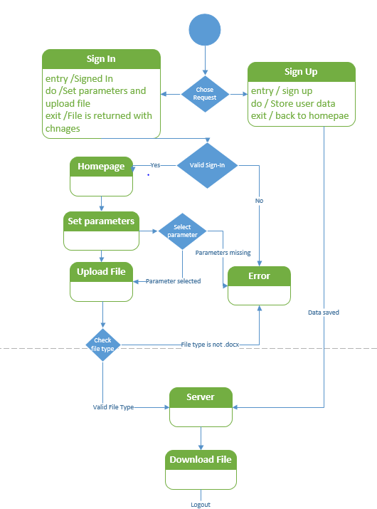
Figure 4. 3 State Transition Diagram

4.2.6 Use Cases
A use case at its most straightforward is a depiction of a client's collaboration with the structure. It exhibits the connection between every one of the entertainers associated with a Software Project. The performer can be a human or other outside structure. It is a usage scenario for a piece of software; often used in the plural to suggest situations where a piece of software may be useful. A potential scenario in which a system receives an external request and responds to it. Use Cases have the accompanying elements:
• Sorting out viable necessities.
• Demonstrating the goals of structure client correspondences.
• Recording circumstances from trigger events or outrageous goals.
• Portraying the fundamental course of exercises and uncommon movement of events.
• Allowing a client to get to the handiness of another event.
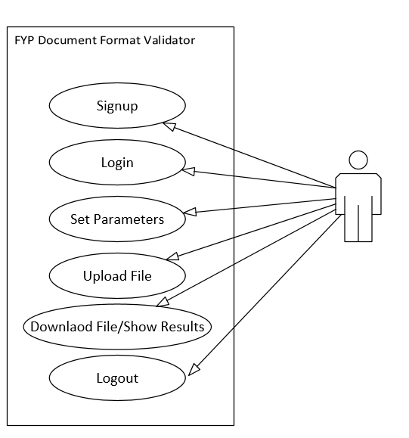
Figure 4. 4 Use Case Diagram

4.2.6.1 Use Case Signup
In Sign-up new user will open website URL and register itself as a first-time user and provide valid email and password. After successful signup user will be able to log in in future for further benefits.
ID | UC01
Description | User Registration
Actors | First time visitors/non-registered user
Preconditions | Working Internet, Web browser
Basic Steps | - Enter the website URL in the web browser’s search bar.  - Click on “Register” button.  - Provide a valid email address.  - Set up a unique password.  - Click on “Sign-up” button.
Alternate Steps | NILL
Exceptions | - Invalid password type (e.g., weak password)
Post conditions | - User is able to login afterwards.
Table 4. 1 Use Case Sign-Up

4.2.6.2 Use Case Sign-In
In log in registered user will enters its credentials valid email and valid password that has been save as his account in database. After entering correct information user will be logged in system.

ID | UC02
Description | Login
Actors | Registered User
Preconditions | Working Internet, Web browser, Registered
Basic Steps | - Enter the registered e-mail address in e-mail given space.  - Enter the set password in password given space.  - Click “Log-in” button.
Alternate Steps | NILL
Exceptions | - Invalid Username or password.
Post conditions | - User is led to home-page.
Table 4. 2 Use Case Sign-In

4.2.6.3 Use Case Set Parameters
When user is registered and signed in homage of website will be show to user where he can set parameter according to which he wants to check the document he is going to upload.

ID | UC03
Description | Set Parameters
Actors | Registered User
Preconditions | Working Internet, Web browser, Registered, Logged-in
Basic Steps | - Select the desired parameters.  - Set their values.
Alternate Steps | NILL
Exceptions | - Parameters not set successfully.
Post conditions | - File is ready to download.
Table 4. 3 Use Case Set Parameters

4.2.6.4 Use Case Upload File
When user has set the parameters successfully the user will b ask to upload file in the system and system after process gives the output file.

ID | UC04
Description | Upload File
Actors | Registered User
Preconditions | Working Internet, Web browser, Registered, Logged-in,
Basic Steps | - Click “Upload” button.  - Select desired file.  - Click “Ok” button.
Alternate Steps | Drag and drop the required file in the “Drag and Drop Box”.
Exceptions | - Slow Internet.  - Invalid File type.
Post conditions | - File is accepted.

Table 4. 4 Use Case Upload File

4.2.6.5 Use Case Download File
When file is been uploaded the user will be given the “Download” button after processing is completed. User can download the modified file by just one click.

ID | UC05
Description | Download File
Actors | Registered User
Preconditions | Working Internet, Web browser, Registered, Logged-in
Basic Steps | - Click the “Download” button.
Alternate Steps | NILL
Exceptions | - File not downloaded.
Post conditions | - Upload another file.  - And repeat the steps.  - Logout.
Table 4. 5 Use Case Download File

4.2.7 Sequence Diagram
A Sequence diagram shows process interactions arranged in time sequence in the field of software engineering. It depicts the processes involved and the sequence of messages exchanged between the processes needed to carry out the functionality. It is worked of a message progression diagram. In this, framework distinguish how the capacities are done in the framework. So, this can help in making the various functionalities in the application. Framework completed a succession chart in each utilization case. First, we have client who can perform two activities. Login in and join. For new client he needs to join. He will enter its subtleties and information will be saved. Also, after fruitful sign up he will actually want to join.
After sign in he will choose boundary and transfer a document. Framework will check for legitimate record type. In the wake of checking document type assuming that its substantial, client’s record is transferred to server to perform necessary processing. After processing framework will return an altered records where missteps are underlined.
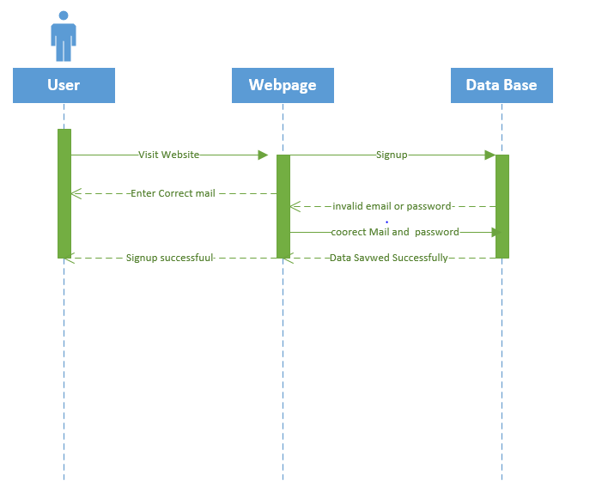
Figure 4. 5 Sign Up Sequence Diagram
In figure 4.5 new user is signing up. User will enter email and set password, on successful steps user will be signed up and data will be saved for future log-in.
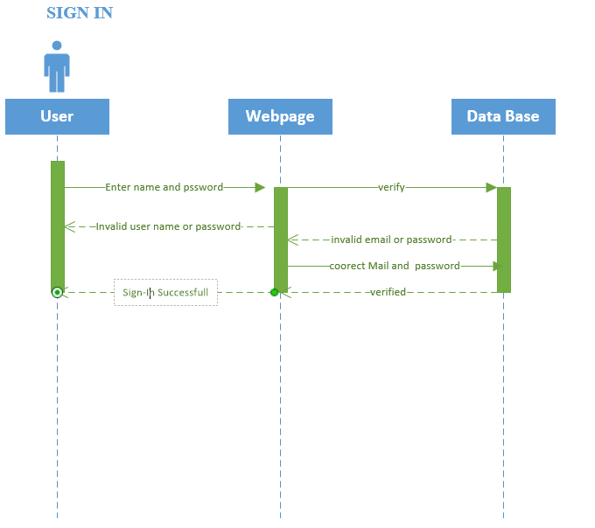
Figure 4. 6 Sign -In Sequence Diagram
In figure 4.6, registered user is signing in to its account to further perform operation. User will enter its username and password if its user name and password is matching with data saved in database, user will be able to log in. If any one of credential is incorrect user will get an invalid username or password prompt. Sequence of steps is very necessary and needs to be followed in correct sequence. If any step-in sequence is missed system will behave different than it is supposed to work.
Complete Sequence Diagram:
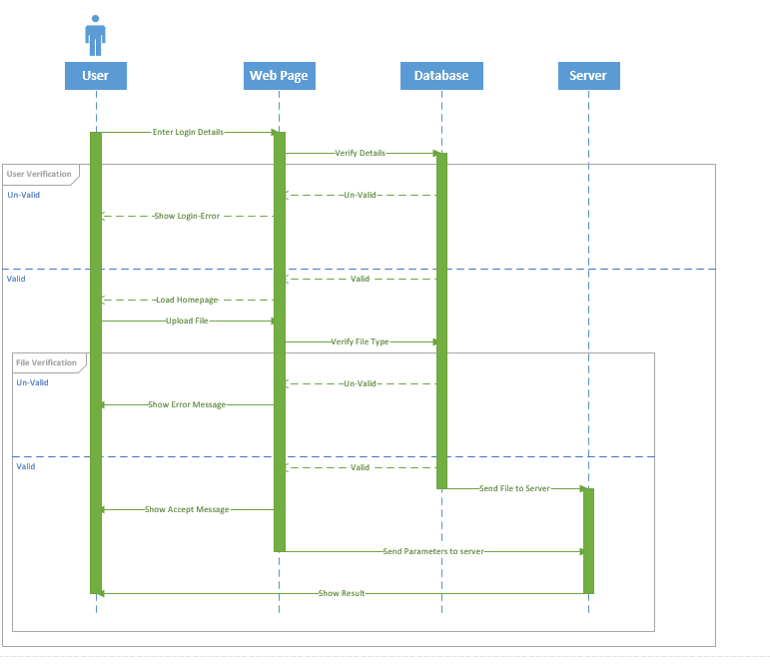
Figure 4. 7 Complete Sequence Diagram

4.3 Implementation Procedure

4.3.1 System Diagram
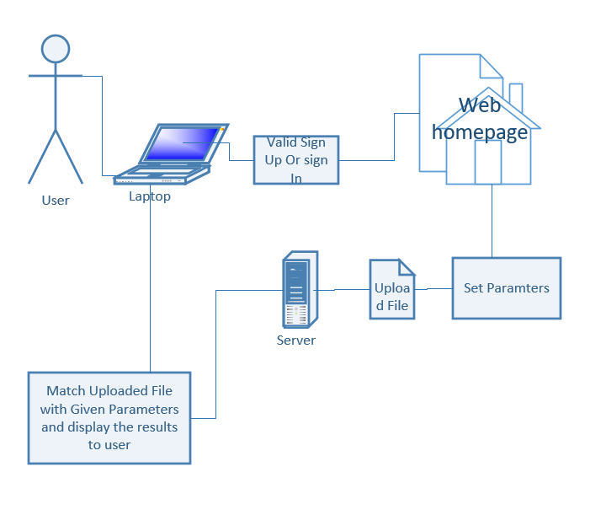
Figure 4. 8 System Diagram

4.3.2 System Description
Our system is very simple. User will open URL of website. If he is a new user, he will sign-up and will be directed to sign-up form page. If he is a registered user he will sign-in. After sign-in home page of system will be shown to user. It has many drop down menu selections for different parameters. After selecting parameters there is a path where user will choose his file in which he wants to check format. Selected file will be uploaded on server. Now server will uncompressed that file and will take the XML file. XML file has all the properties information like font size etc. used in word document. Server will match XML file properties i.e., Font-Style, Font-Family if the selected property matches with XML File property its system will ignore that and continue to check next property. When property will not match system will underline the word or line with color scheme according to error found. After file is read completely system will return the modified file where unmatched text will be highlighted by underline.

4.3.3 Front End
The front end of this product is developed in React JS. In this phase of the front end, developer also use the Html, CSS which is also a part of React JS. These are the design which is created from react js is showing below:

4.3.3.1 Sign up Page
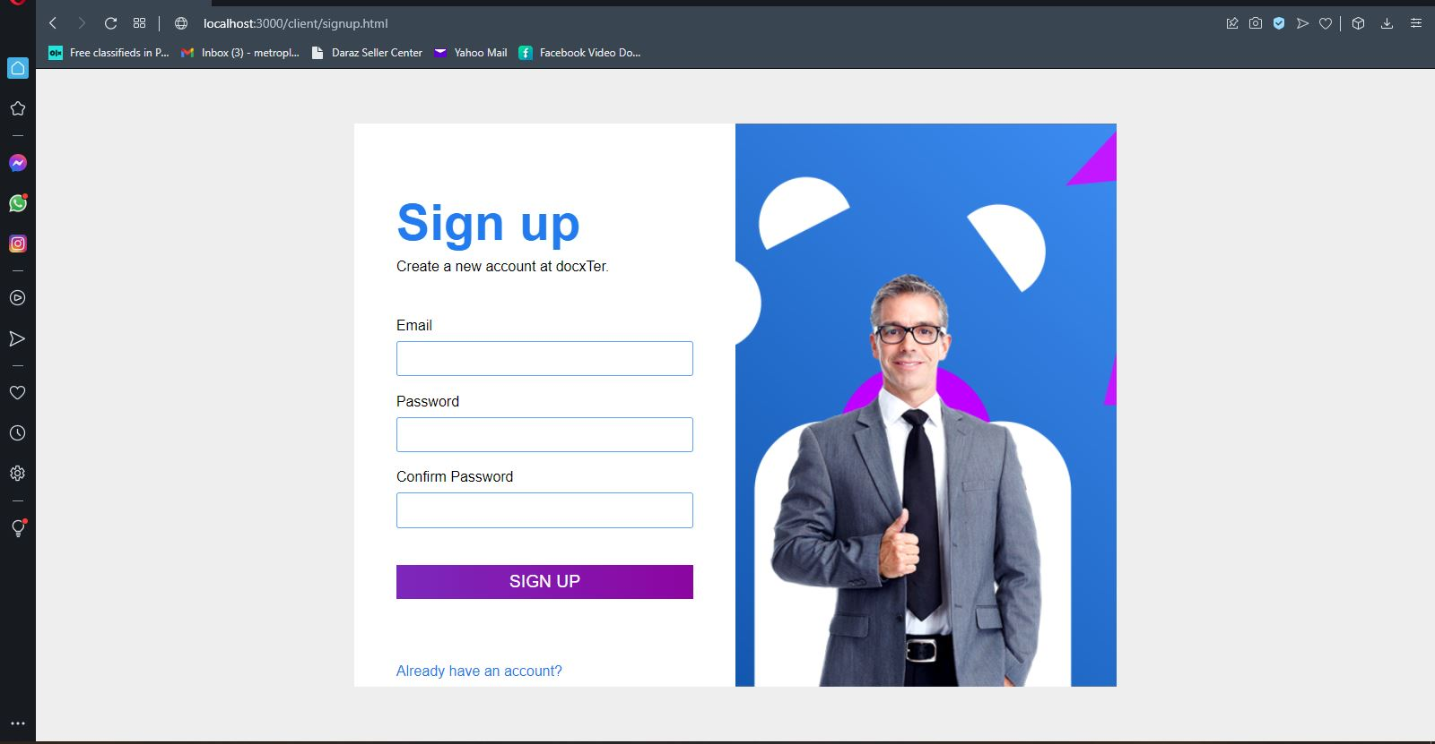
Figure 4. 9 Sign-Page
In figure 4.9 is a signup page where the user will enter any email and then select a password for him/her. Then the user will be asked to re-enter the password. Then the User will click signup and his data will be saved for future log-in.

4.3.3.2 Sign in Page

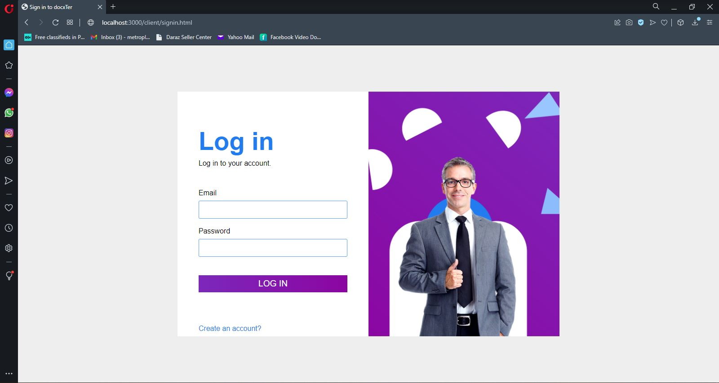
Figure 4. 10 Sign-In Page
In figure 4.10 At this, the user is asked to enter a valid email and password in order to log in to their account and use the features of website. If it’s a new user then he will click at “Create an account” and will be directed to signup page.

4.3.3.3 Main Menu
At this page, the user presets all the parameters and then uploads any document to validate its format. The document will be validated and a download button will appear to download modified file.

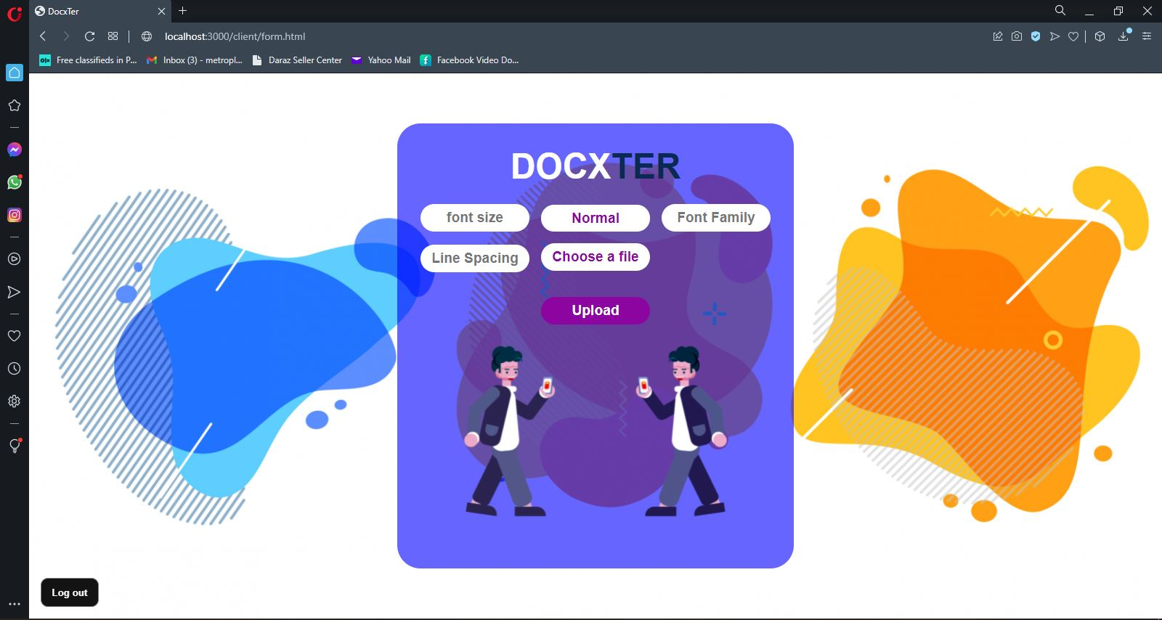
Figure 4. 11 Main Menu
In figure 4.11, there is menu of our system. Number of properties can be checked. User can select different properties and upload file on system. User will be given a modified file.

4.3.4 Back End
At the back-end Node JS has been used for development and performing all the operations. Fire database has been used for user verification.

4.4 Verification of Functionalities
Functionalities in software system are verifiable and validated according to the need requirement of the system. The verification of functionalities is following:

4.4.1 Sign in Verification
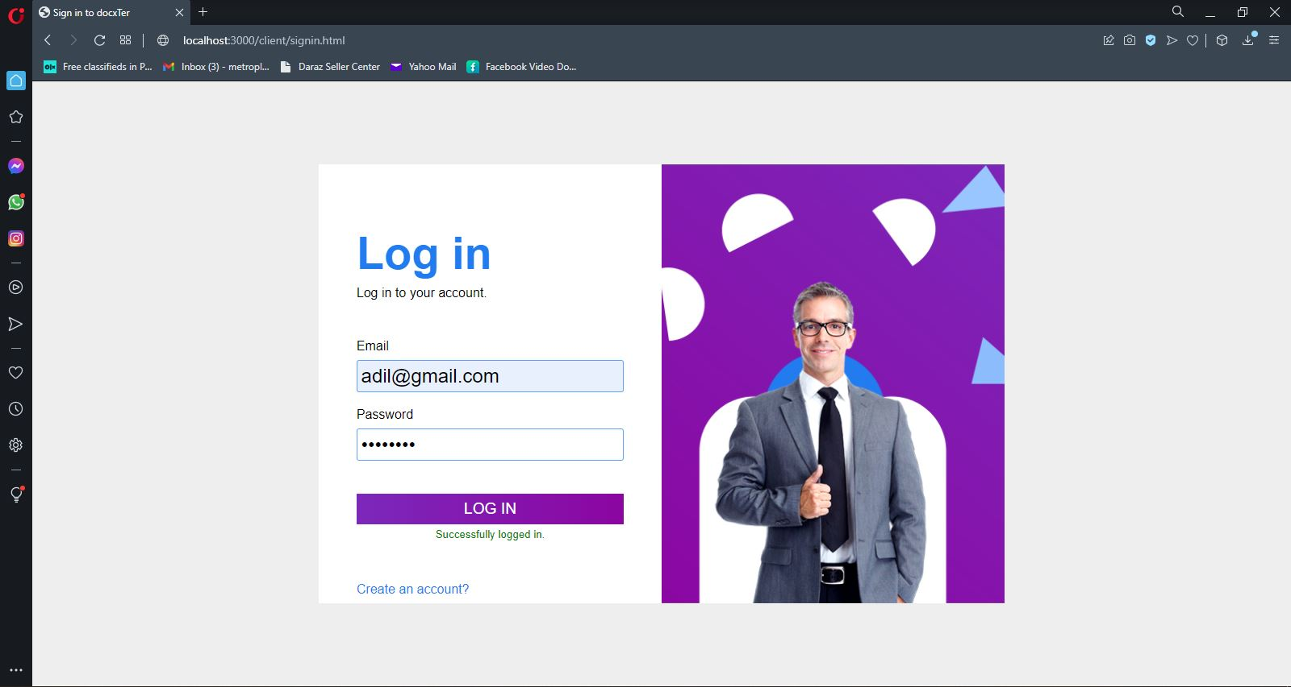

Figure 4. 12 Successfully Signed-In
In figure 4.12 There is a sign-in page, where users can log in to their accounts. Users must enter their email and their password to log in on the dashboard. After entering correct information, the website shows a notification “Successfully logged in”. Now the user can perform all the operations provided.

4.4.2 Invalid password
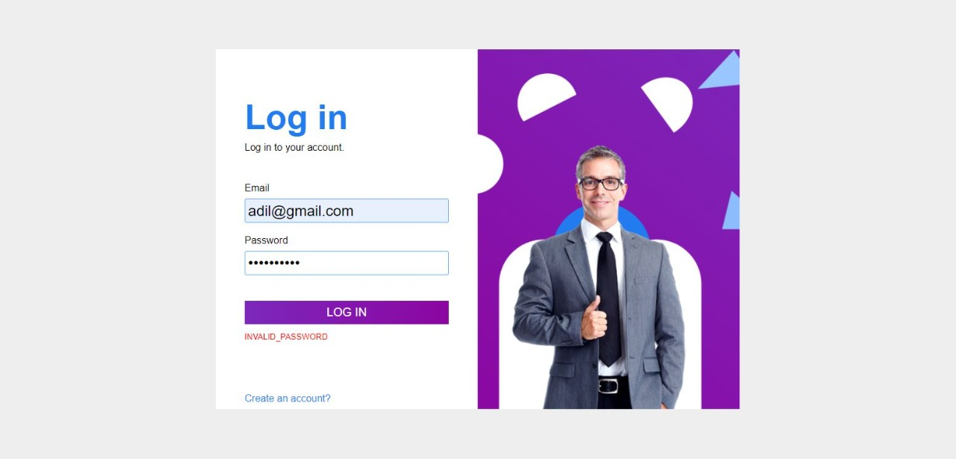
Figure 4. 13 Invalid Sign-In
In figure 4.13 as you can see you cannot login with incorrect password or email. The user who is accessing its account has to remember its password. If he forgets his password, he will not be able to access its account.

4.4.3 Sign up Verification

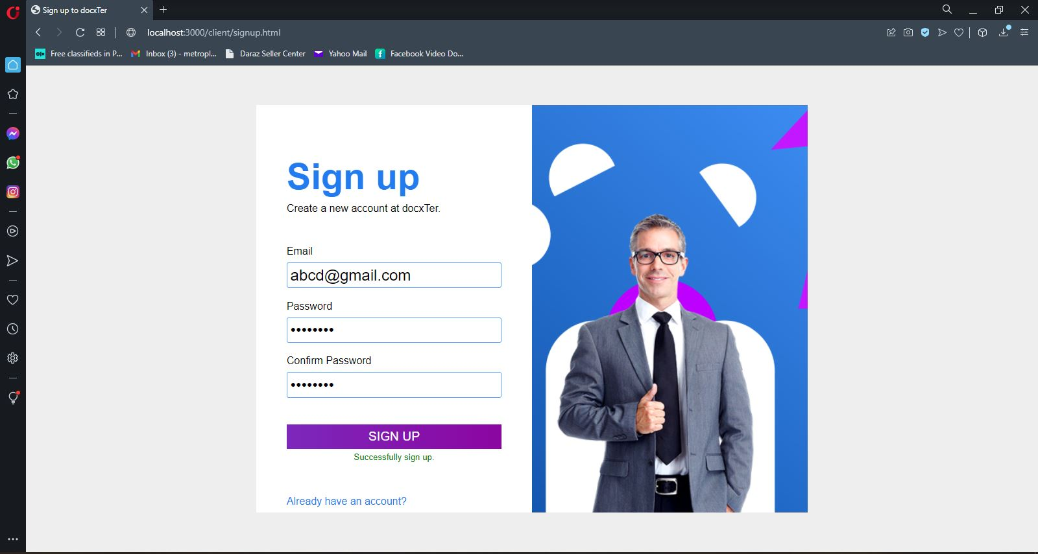

Figure 4. 14 Sign-Up Successful
In figure 4.14 there is a signup page, where users can sign up their accounts. Users must enter their email and a password and then re-enter password for confirmation. After entering correct information, the user can login now to use the website.

4.4.4 Unregistered User
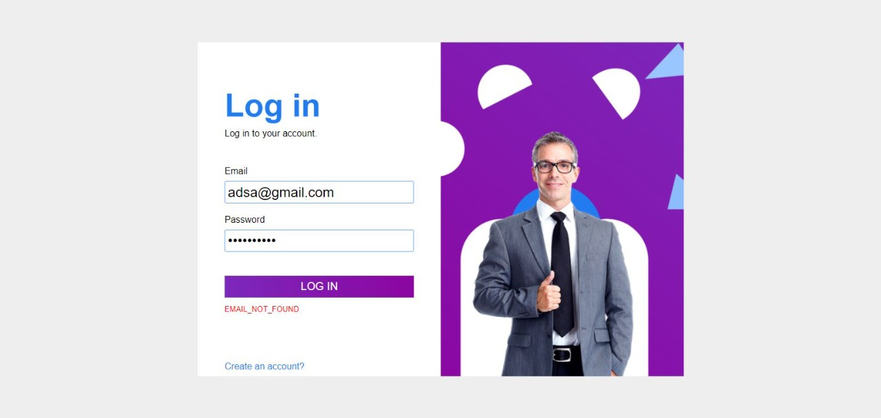
Figure 4. 15 Unregistered User

In the figure 4.15 we can see the system is not allowing any unregistered user to sing-in. User can only sign in if he already signed up. This functionality is working correctly. System will block any user that is not signed up and will not be allowed to sign in until he is signed up on our website.

4.4.5 Password not matched
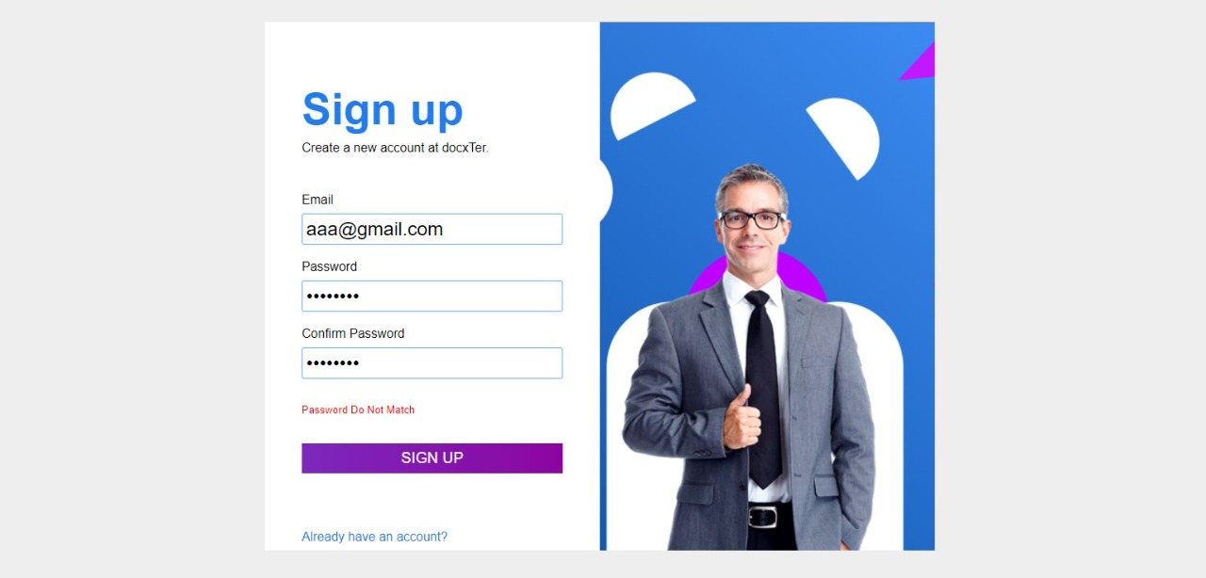
Figure 4. 16 Password Not Matched

In figure 4.16 it is clear that if password do not match new user won’t be able to complete signup. When user is trying to sign up system will ask user to repeat password. If password matches users’ data will be saved for login authentication. If user password does not match it will throw an error that password does not match.

4.4.6 Invalid Email
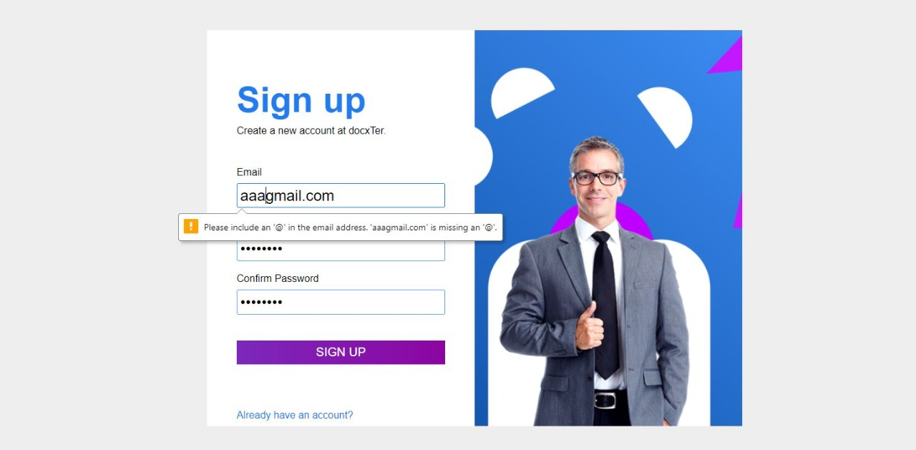
Figure 4. 17 Invalid Email
In figure4.16, invalid email is being recognized and message is prompted that your email is invalid. If new user is typing invalid email system will let the user know that you are typing invalid email.

4.4.7 File Uploading
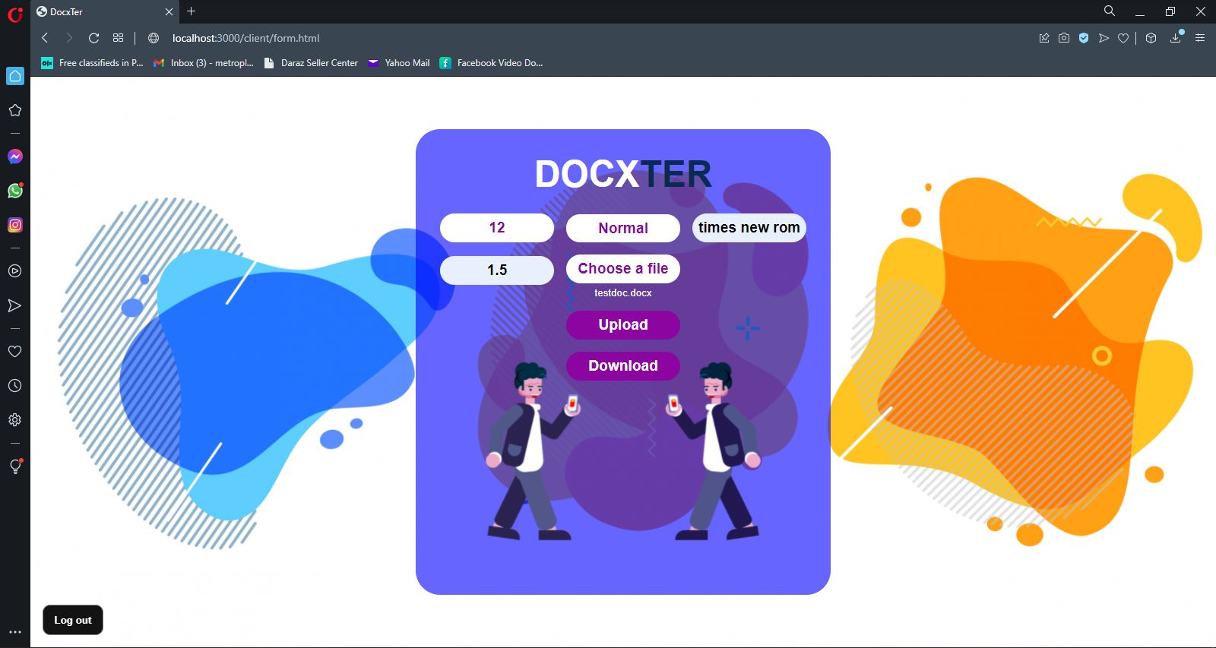
Figure 4. 18 File Upload Successful
In figure4.18, the chosen file has been uploaded and all the required properties are set. To download the modified file a download button appears when the processing is completed in the back end.

4.4.8 Downloaded File Content
When we uploaded a file in Document Format Validator it returned a file back with modification in it the format which is not matching with given was highlighted in different color schemes for example table error color is red, image error color is yellow and so on.
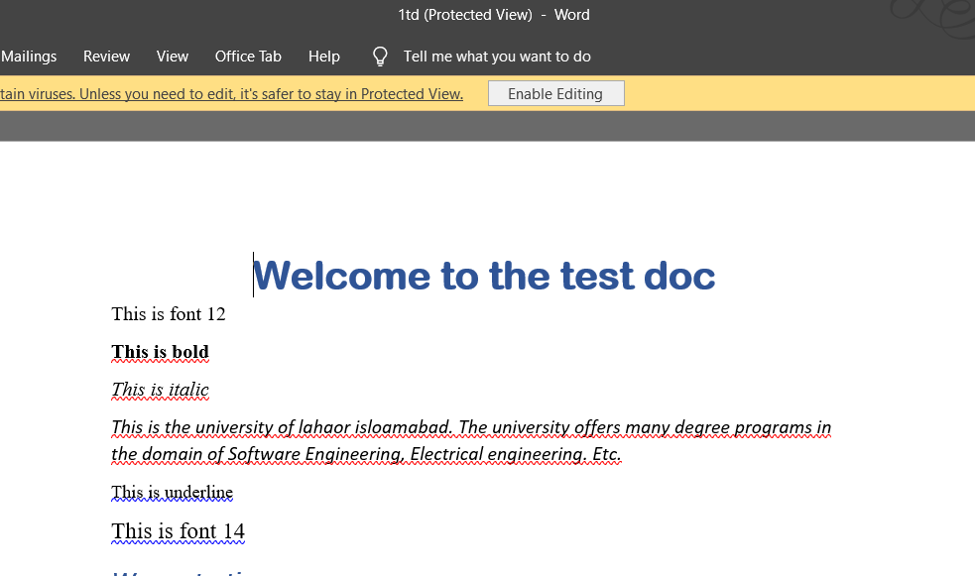
Figure 4. 19 Test Document 1
In Figure 4.19 first line is not highlighted because we have selected the size 12, normal text style and font-family was Times New Roman. The system did not highlight text that match with our given parameter instead it highlighted remaining text that is not matching.
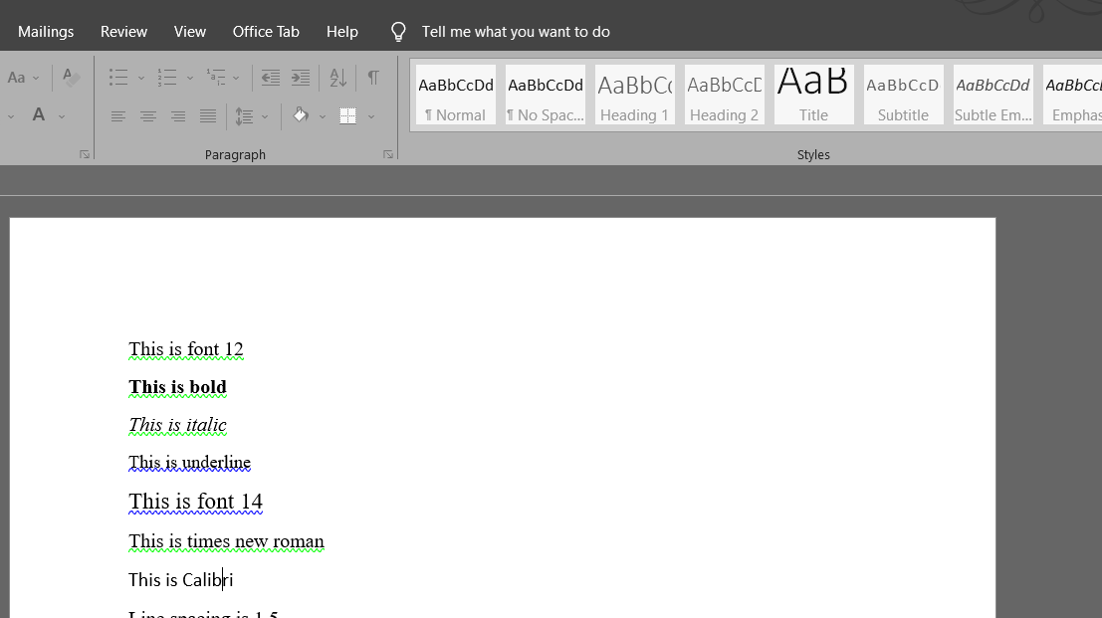
Figure 4. 20 Test Document 2
In the figure-4.20 we have changed the font family to Calibri and remaining properties were same you can see it highlighted the first line too because that was not matching with our given parameters.
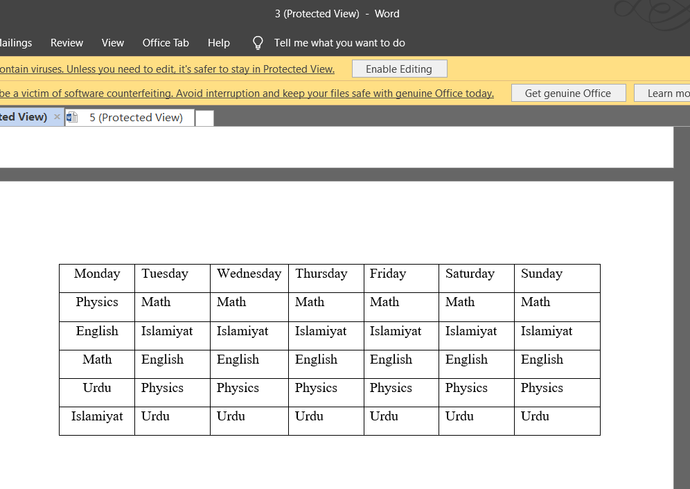
Figure 4. 21 Correct Table
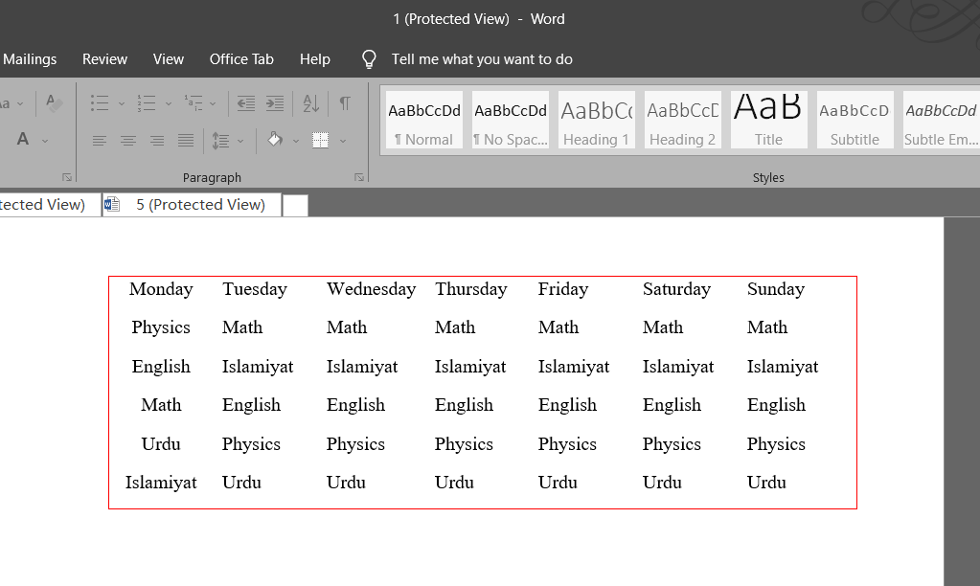
Figure 4. 22 Incorrect Table
In figure 4.21 we have set the table alignment to center when we were setting parameter in document. When we uploaded the file table alignment was centered so its not highlighted. When we changed the alignment of same table and uploaded again the result in Figure 4.22 was that the borders of table were changed to red because it was not matching with our set parameters.
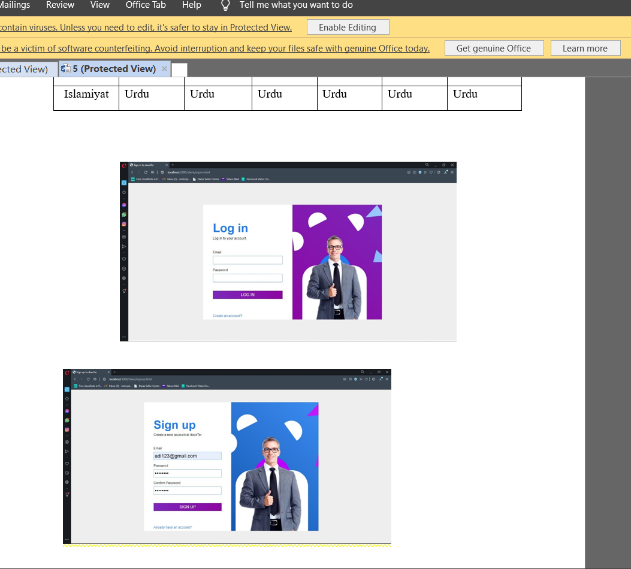
Figure 4. 23 Picture Test Document
In Figure 4.23 we have set the alignment of pictures by default center aligned. As it is clear the first picture is centered align so it is not highlighted. Whereas second picture is not centered so that’s why there is a yellow line showing under the second picture.
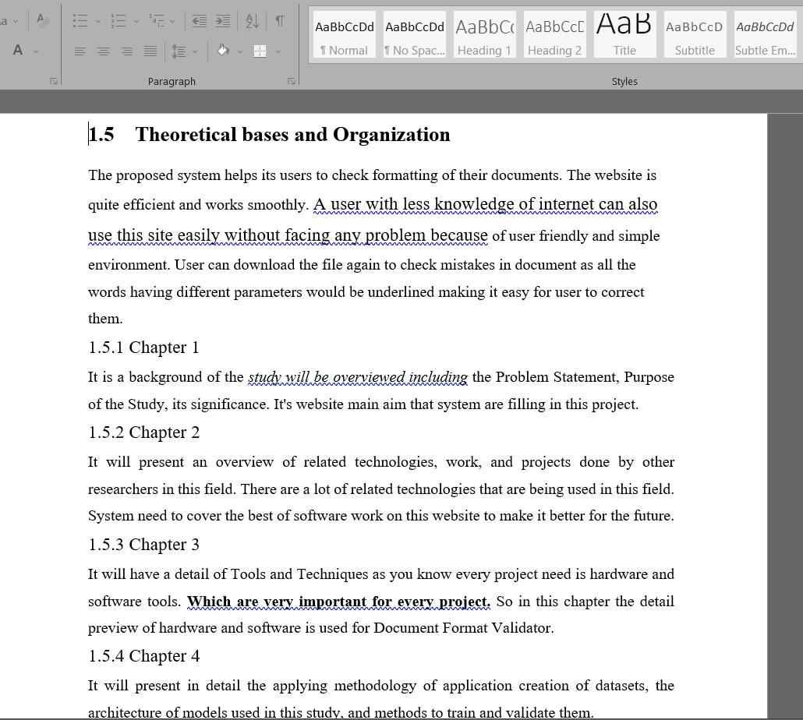
Figure 4. 24 Final Report Test Document 1
In Figure 4.24 we have uploaded our final report that has to be submitted and selected the parameters Text size 12, Font-Family was Times New Roman and text style was Normal. After uploading the file, we have the downloaded the processed file and result are in front of us that it worked right.

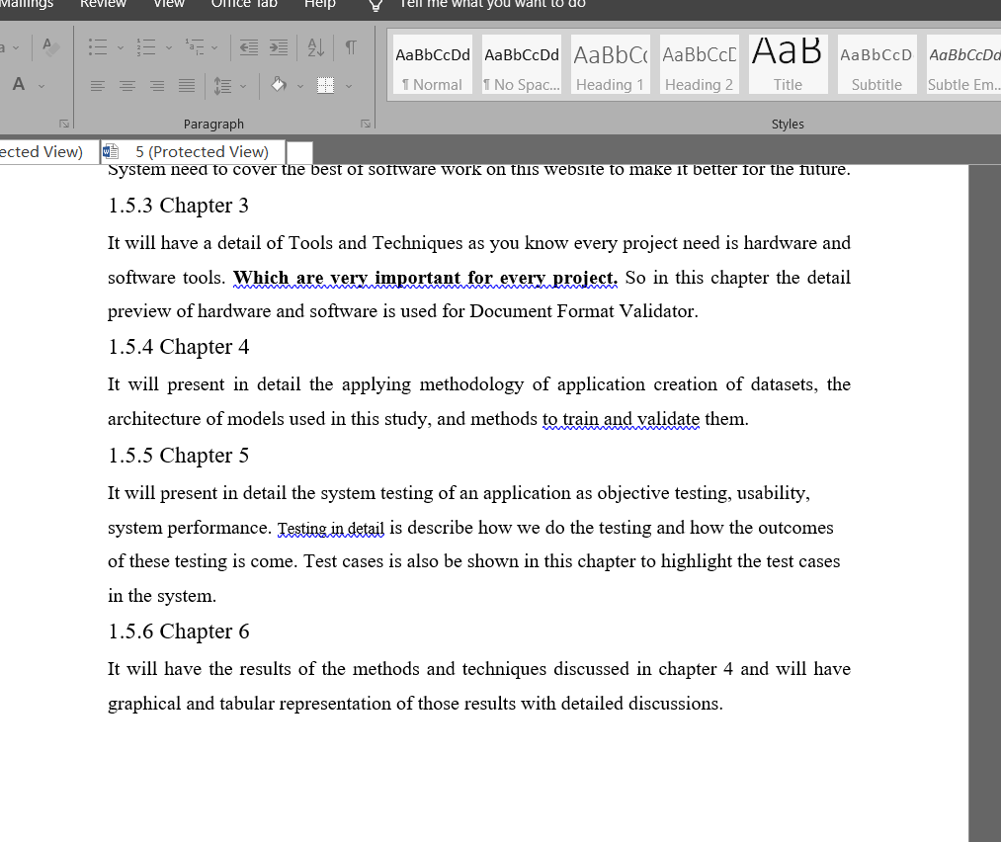
Figure 4. 25 Final Report Test Document 2
In figure 4.25 we have tested our final report by making some changing by bolding some text and you can see it worked perfectly.

4.5 Summary
In the chapter 4, this is the description of Methodologies used is provided. How developers do these things and make the design, implementation, and verification of the system. We made sure that our system is working perfectly. For that we have verified the functionalities of our system. We analyzed the system and complete its design and implementation and find out the system is working as expected.

Chapter 5

SYSTEM TESTING
Testing is critical for the accomplishment of any item. Each task isn't 100 percent. Testing is moreover conveyed in two phases. The main stage is during the programming that is during the formation of modules. The subsequent stage is after the accomplishment of the site. This is trying that checks the whole game plan of ventures hanged together.

5.1 Objective Testing
The principal objective of goal testing is to guarantee the possibility of the site is passed on. Test Objective is the general objective and accomplishment of the test execution. The target of the testing is to observe at any rate various item flees as could be possible. It should ensure that the item under test is without bugs preceding dispatching the endeavor.
We have completed our project and perform objective testing and came to following results.
- We have achieved 100% objective.
- We checked every functionality of system. All of them are working fine.
- Execution time of system is 2-3 seconds.

5.2 Usability Testing
Convenience testing is a strategy for testing the usefulness of a site, application, or other advanced item by noticing genuine clients as they endeavor to follow through with jobs on it. The clients are typically seen by specialists working for a business. We asked the project coordinator and our universities fellows who have to submit FYP reports to use our website. 27 out of 30 students was satisfied with the usability of the system

5.3 Software Performance Testing
This testing is executed for the checking of the efficiency and unflinching nature of the site. It chooses the time that the venture, used by the framework to manage trade data. This test is driven before execution to conclude what measure of time it expects to get a response to a solicitation or boat off the transmission and get a response. This will ensure your site works under all loads.
We asked 15-20 students to user our website simultaneously. The response time of website is recorded 1.3- 1.9 seconds. And response time in downloading file from server

5.4 Compatibility Testing
Similarity testing is utilized to make sure that your web application can be run on each stage or gadget. This would include:

5.4.1 Browser Compatibility Test
Assuming that your web application is running precisely on every one of the stages or gadgets. We made sure it is working same on phone as it is working on laptop

5.4.2 Rendering of Element
Each element is rendered same. No data is moved or changed when we changed the gadget. The site ended up incredible for each framework

5.5 Load Testing
Load testing is utilized to take a look at the heap on the site. What number of people/groups can utilize it at one time? On the off chance that any site can single out the weight of a site, analyzer can say the heap testing of that site is great and proficient. In performing load testing, analyzer need to reenact clients will use your web application in all actuality.
We added load of 100 people using website at once. The website did not crash and each person who was using website had the good performance and no glitch recorded.

5.6 Reliability Testing
Dependability Testing is a trying cycle that checks whether the product can play out a disappointment free activity for a predetermined time frame period in a specific climate. The motivation behind Reliability testing is to guarantee that the product item is without bug and solid enough for its normal reason.
We make sure that our website will be 95% of the time making it reliable for user. They can use it whenever they want irrespective if the time.

5.7 Security Testing
Security Testing is essential for site that stores sensitive client information like individual information. With the immense number of extraordinarily capable software engineers in the world, security should be a colossal concern for anyone developing a web application. Analyzer need to test how secure your web application is from both external and inside risks. Testing a web application can be a completely overwhelming task. All that direction can give client is to keep zeroing in on and focusing in on the primary pieces of your application and make sure to demand help from your fellow partners. Testing Activities will include:
- Client Authorization.
- On usage of SSL confirmations, the site ought to divert to the encoded SSL page.
We checked with wrong login credentials and with correct as well. No unauthorized client is able to log in to the system. You can only log-in when you have correct credentials. Client authorization is working perfectly well and SSL is working great.

Database Testing
Database testing is on the off chance that any slip-ups are displayed while endeavoring questions and C\check the reaction season of each inquiry which utilized in a data set.
Database is working fine signed up user data is saved and on basis on that they can’t log in. response time of database is very high mean there is less delay on fetching data from database.

5.9 Test Cases
An experiment is a narrative, which has a great deal of test information, preconditions, expected outcomes activities, and results, made for a specific test situation to avow consistency against a particular need.
Test Case # 01
Test Case Name: Sign Up for new user
Test Description: New use will register itself on website.
Testing Environment: Functional Testing
Test ID: 01
Preconditions | User must have valid email.
Actions | Enter email and password and then click on “Sign up” button.
Expected Results | Sign up completed and user is added to record
Result | Sign up Successful.
Table 5. 1 Test case 1 Functional Testing
Test Case # 02
Test Case Name: Login
Test Description: User will login with its email and password.
Testing Environment: Security Testing
Test ID: 02
Preconditions | User must be registered.
Actions | Enter email and password and then click on “Log in” button.
Expected Results | Logged in as user.
Result | Login Successful.
Table 5. 2 Test Case 2 Security Testing
Test Case # 03
Test Case Name: Select Parameters.
Test Description: User will select document parameters from a drop-down menu or by typing certain parameters.
Testing Environment: Functional Testing
Test ID: 03
Preconditions | - User must be registered.  - User must be logged in.
Actions | Select parameters from drop down menu on home page.
Expected Results | Parameter selected correctly.
Result | All Parameter need to be checked are selected.
Table 5. 3 Test Case 3 Functional Testing
Test Case # 04
Test Case Name: Upload File
Test Description: User will upload file in which he wants to check format.
Testing Environment: Database Testing
Test ID: 04
Preconditions | - User must be registered.  - Must be logged in.  - Parameters are selected.
Actions | Click on “upload file” and chose your file.
Expected Results | File will be uploaded.
Result | File Uploaded successfully.
Table 5. 4 Test Case 4 Database Testing
Test Case # 05
Test Case Name: Download file
Test Description: User will download file which contain results of its uploaded file
Testing Environment: Performance Testing
Test ID: 05
Preconditions | - User must be registered.  - Must be logged in.  - Parameters are selected.  - File is uploaded on server.
Actions | Click On “Download” Button.
Expected Results | File is downloaded.
Result | File downloaded successfully.
Table 5. 5 Test Case 5 Performance Testing
Test Case # 06
Test Case Name: Sign-out
Test Description: User will sign-out after completing its tasks.
Testing Environment: Functional Testing
Test ID: 06
Preconditions | - User must be registered.  - Must be logged in.
Actions | Click On “Sign-out” Button.
Expected Results | Return to sign in page.
Result | Sign-out Successful.
Table 5. 6 Test Case 6 Functional Testing

5.10 Summary
In this chapter, we performed testing of our system. We check user interface and other factor that are important for any website. We also conducted security, usability, reliability, portability, performance and database testing. We made test case and checked every scenario and come to the results that our system is working fine.

Chapter 6

RESULTS AND CONCLUSION
This project has not been an easy task, providing a platform where teachers, students or anyone could recheck formatting of their documents. The main goal of future is providing the best services and functions at a single platform to everyone. Timely updates will be launched to improve user experience and remove bugs.

6.1 Presentation of the Findings
Today every person is familiar with documents. Teacher, Students, office workers in short, every 6 to 7 people out of 10 has to work with document. And important thing of document is its structure/format. There was no platform to check the format so we met with several person and asked them of difficulty they feel checking documents format manually. We are confident that our product will help those people who are checking format manually. After huge effort of our group, we finally able to made the Document Format Validator that helps in format checking and making their life easy. As this is initial version there is some function missing, we ought to give updates timely to make this project a complete one

6.1.1 Hardware Results
The project is completely software based. No hardware involved.

6.1.2 Software Results
The project was basically introduced to reduce the work load of people having lives revolving around documents and formatting such as students and teachers. The website is completely secure and provides better services than other related works.
- Secure Environment.
- Greater Effectiveness.
- Time efficient.
- Simple and User Friendly
- Precise and Accurate

6.2 Discussion of the Findings

6.2.1 Comparison with Initial GOAL
The basic idea behind this project was to provide a time efficient and easy way to validate formats of documents, and after a lot of research and practice and hard work we have achieved our goal. We made this happen and completed this project. There are some features missing but there will be an upgradeable model having updates time to time.

6.2.2 Reasoning for Short Comings
Some of the formatting properties are missing yet as it was just a basic model to test whether it goes as planned or not. The developers did a great job and other features will be added to the base model soon.

6.3 Limitations
The project had a clear issue to be solved and the developers did everything to make that happen yet there remain some shortcoming which are expected to be solved very soon. To make it more time efficient many features were not yet added to the base model moreover:
- The system only accepts doc files as input.
- Internet Connection is required for project to work Properly

6.4 Recommendations
Anyone looking to take part in this project should check the website first. If they think of something new that can be productive or something that is missing, they should go for it.

6.5 Summary
Document Format Validator can provide an accurate, secure, strong, and fast organization structure. It is helping the user to focus on their activity. Thus, it will help in better utilization of resources. The aim is to reduce the work load of people and help them in saving their time and energy within just a few clicks. The system with the help of website, fulfilling their requirements, so that their valuable documents can be formatted easily.

6.6 Conclusion
The requirements to which this website has been developed were not solved before as it isn’t considered a big issue, but as the world is going digital, mostly the need will also rise. Moreover, this project is quite user friendly and simple to use, and provides the basic features to validate any document. Moreover, this website will be followed by proper updates to keep the user interface simpler and bug free, and adding new features and properties to that the user could enjoy more perks at one place. All the working has been done effectively and the website will be launched soon with much more features. As the requirements for such systems rise daily, Document Format Validator will provide everything needed to be the best in the market.

Chapter 7

FUTURE WORK
There is number of tasks we can perform in future work because word document is combination of many factors and that is impossible to cover all factors in our project. So, we have decided to put some work for future that is described below:

7.1 Paragraph Spacing
Paragraph spacing determines the amount of space above or below a paragraph. When you press Enter to start a new paragraph, the spacing is carried over to the next paragraph, but you can change the settings for each paragraph. We will add this as a new parameter in future in word documents in our project.

Indentation
Left Line Indent Indents all the lines of the paragraph a specified distance from the left margin. Right Line Indent Indents all the lines of the paragraph a specific distance from the right margin. Hanging Indent Indents all the lines of the paragraph a specific distance from the left margin except the first line.

Margins
Margins are the blank spaces that line the top, bottom, and left and right sides of a document. It helps to align the structures of documents correctly. We will add this parameter in future.

Header and Footer Content
A header is text that is placed at the top of a page, while a footer is placed at the bottom, or foot, of a page. Typically, these areas are used for inserting document information, such as the name of the document, the chapter heading, page numbers, creation date and the like. We will check their content in future.

Text Color
The Font Color button shows which shading it relegates to message. To change the shading, click the menu triangle to the button's left and pick a shading from the menu showed. To reestablish the text style tone, pick Automatic from the Font Color menu. The Automatic tone is set by the text style.

Bullet list
A bullet is normally a dark circle, yet it very well may be some other image used to feature things in a rundown. Use projectiles to list things that don't need to be in a specific request. Numbers-or letters-are utilized when data should be in a specific request. We will work on this property in future.

Tables Cell Contents
Tables oversee credits. This implies they store data. In a geodatabase, tables as a rule store data about a geographic element. Tables contain lines. Each column is one record. In a spatial table, each line addresses one component. All lines in a table have similar sections. Sections are likewise called fields. They are the classifications of data the table contains, like names, regions, situations with, ID numbers. Each field has an information type and a name. We will check cell detail deeply,

Summary:
There is unlimited number of actions we can perform in our future project. We will check spacing between lines as well as paragraphs. Page margins are very crucial in a format of document we will also check margins as well as indentation of text and paragraphs.

REFERENCES
[1]. Anwar, O. 2007, RF Controlled Audio/Video Vehicle, BS Project Report, Mohammad Ali Jinnah University, Islamabad, Pakistan
[2]. Brandli G. and Dick M., “Alternating current fed power supply,” U.S. Patent 4 084 217, Nov. 4, 1978.
[3]. Chen W. K., Linear Networks and Systems. Belmont, CA: Wadsworth, 1993, pp. 123–135.
[4]. Duncombe J. U., “Infrared navigation—Part I: An assessment of feasibility,” IEEE Trans. Electron Devices, vol. ED-11, pp. 34–39, Jan. 1959.
[5]. Ebehard D. And Voges E., “Digital single sideband detection for interferometric sensors,” presented at the 2nd Int. Conf. Optical Fiber Sensors, Stuttgart, Germany, 1984.
[6]. Miller E. H., “A note on reflector arrays,” IEEE Trans. Antennas Propagat., to be published.
[7]. Payne D. B. And Stern J. R., “Wavelength-switched passively coupled single-mode optical network,” in Proc. IOOC-ECOC, 1985, pp. 585–590.
[8]. Reber E. E., Mitchell R. L., and Carter C. J., “Oxygen absorption in the Earth’s atmosphere,” Aerospace Corp., Los Angeles, CA, Tech. Rep. TR-0200 (4230-46)-3, Nov. 1968.
[9]. Smith, J., Masud, F. & Linda, A. 2005, Some good work in a good conference, IEEE International Conference, USA, Vol. vv(issue), pp. 11-22.
[10]. Vidmar. R. J. 1992, Aug. On the use of atmospheric plasmas as electromagnetic reflectors. IEEE Trans. Plasma Sci. 21(3), pp. 876–880.
[11]. Wigner E. P., “Theory of traveling-wave optical laser,” Phys. Rev., vol. 134, pp. A635–A646, Dec. 1965.
[12]. “Orthogonal frequency-division multiplexing”, available online at ‘http://en.wikipedia.org/wiki/Orthogonal_frequency-division_multiplexing’ on 02/10/2012

APPENDICES
Appendix – A
